Creating a Probability Game Based on Story

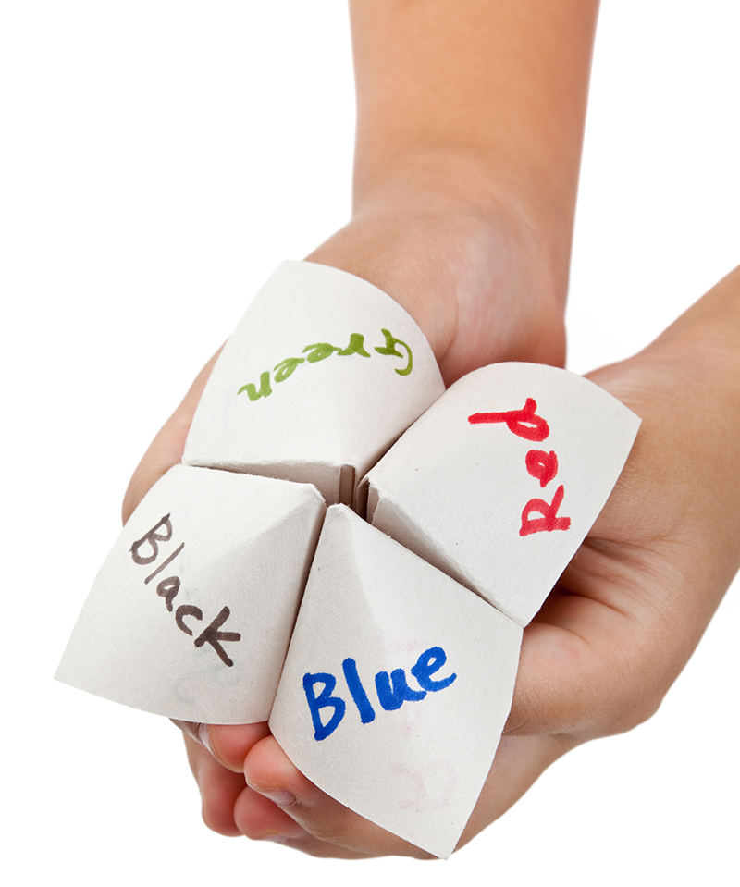

A Cross-Curricular Learning Activity for Grade 4 Mathematics, Applied Design, Skills and Technologies and English Language Arts
Acknowledgements & Copyright
2016 © Province of British Columbia

The new BC Curriculum reflects a shift towards a concept-based, competency-driven curriculum. The new curriculum is less prescriptive than before, allowing educators to be creative and innovative in their design of learning experiences, and offering flexibility and choice for teachers and students.
The new curriculum promotes higher-order thinking and deeper learning centred on the ‘Big Ideas’ in each discipline. Core competencies related to Thinking, Communication, and Personal and Social Responsibility are explicit, and First Peoples’ Principles of Learning are integrated throughout.
This resource is a lesson plan designed to address the learning standards and core competencies outlined in the new BC Curriculum for Grade 4 Mathematics, Applied Design, Skills and Technologies, and English Language Arts. It was developed by Open School BC, Ministry of Education in partnership with the provincial Curriculum and Assessment team and BC teachers.

Contributors
Josh Angiola
Sean Cunniam
Dorothy Galvin
Kerry McBride
Rachel Mason
Farrah Patterson
Maureen Postnikoff
Jennifer Riddel
Chris Teskey

Rationale

We were looking for a cross-curricular way to address probability content in Grade 4 Mathematics and content from Applied Design 4, which is new to the curriculum. We came up with the idea of making a game of chance, because we felt that the process of creating a game would reinforce new concepts in math and applied design by giving students an opportunity to apply these concepts in practice.

We also wanted students to use both written and oral expression skills to communicate how their game works. We chose to include a focus on storytelling (both in the entry points and the game creation) as a valuable way to communicate information and engage attention. This will also encourage students to explore how stories help us to make sense of the world. Students will practice using different forms of communication for different purposes when they create both a story and instructions for their game.

Most importantly, we wanted this activity to be fun, so students will experience math in a positive and playful way and will increase their confidence in their learning. This document includes a series of activities that teachers can choose from, add to, adapt, or incorporate into other lessons. All of the activities are intended as suggested approaches that can be tailored by teachers according to the needs of their students.
The focus on storytelling was also selected as an effort to incorporate First Peoples principles of learning. While the lesson does not explicitly include First Peoples content, the notion of using oral stories as a tool to communicate teachings aligns with First Peoples pedagogical approaches. Two of the entry point activities involve teachers telling students an oral story to communicate mathematical concepts (although there is also an option to use a storybook). Students then have an opportunity to practise telling oral stories when creating their games. To highlight the value of storytelling and its importance in First Peoples cultures, teachers may consider incorporating some direct instruction in storytelling methods. The following resources may be useful:
- Teaching Storytelling the Classroom — a short video based on the book Children Tell Stories, by Martha Hamilton and Mitch Weiss
- First Nations Pedagogy Online — teacher resources on storytelling and other First Nations approaches to teaching

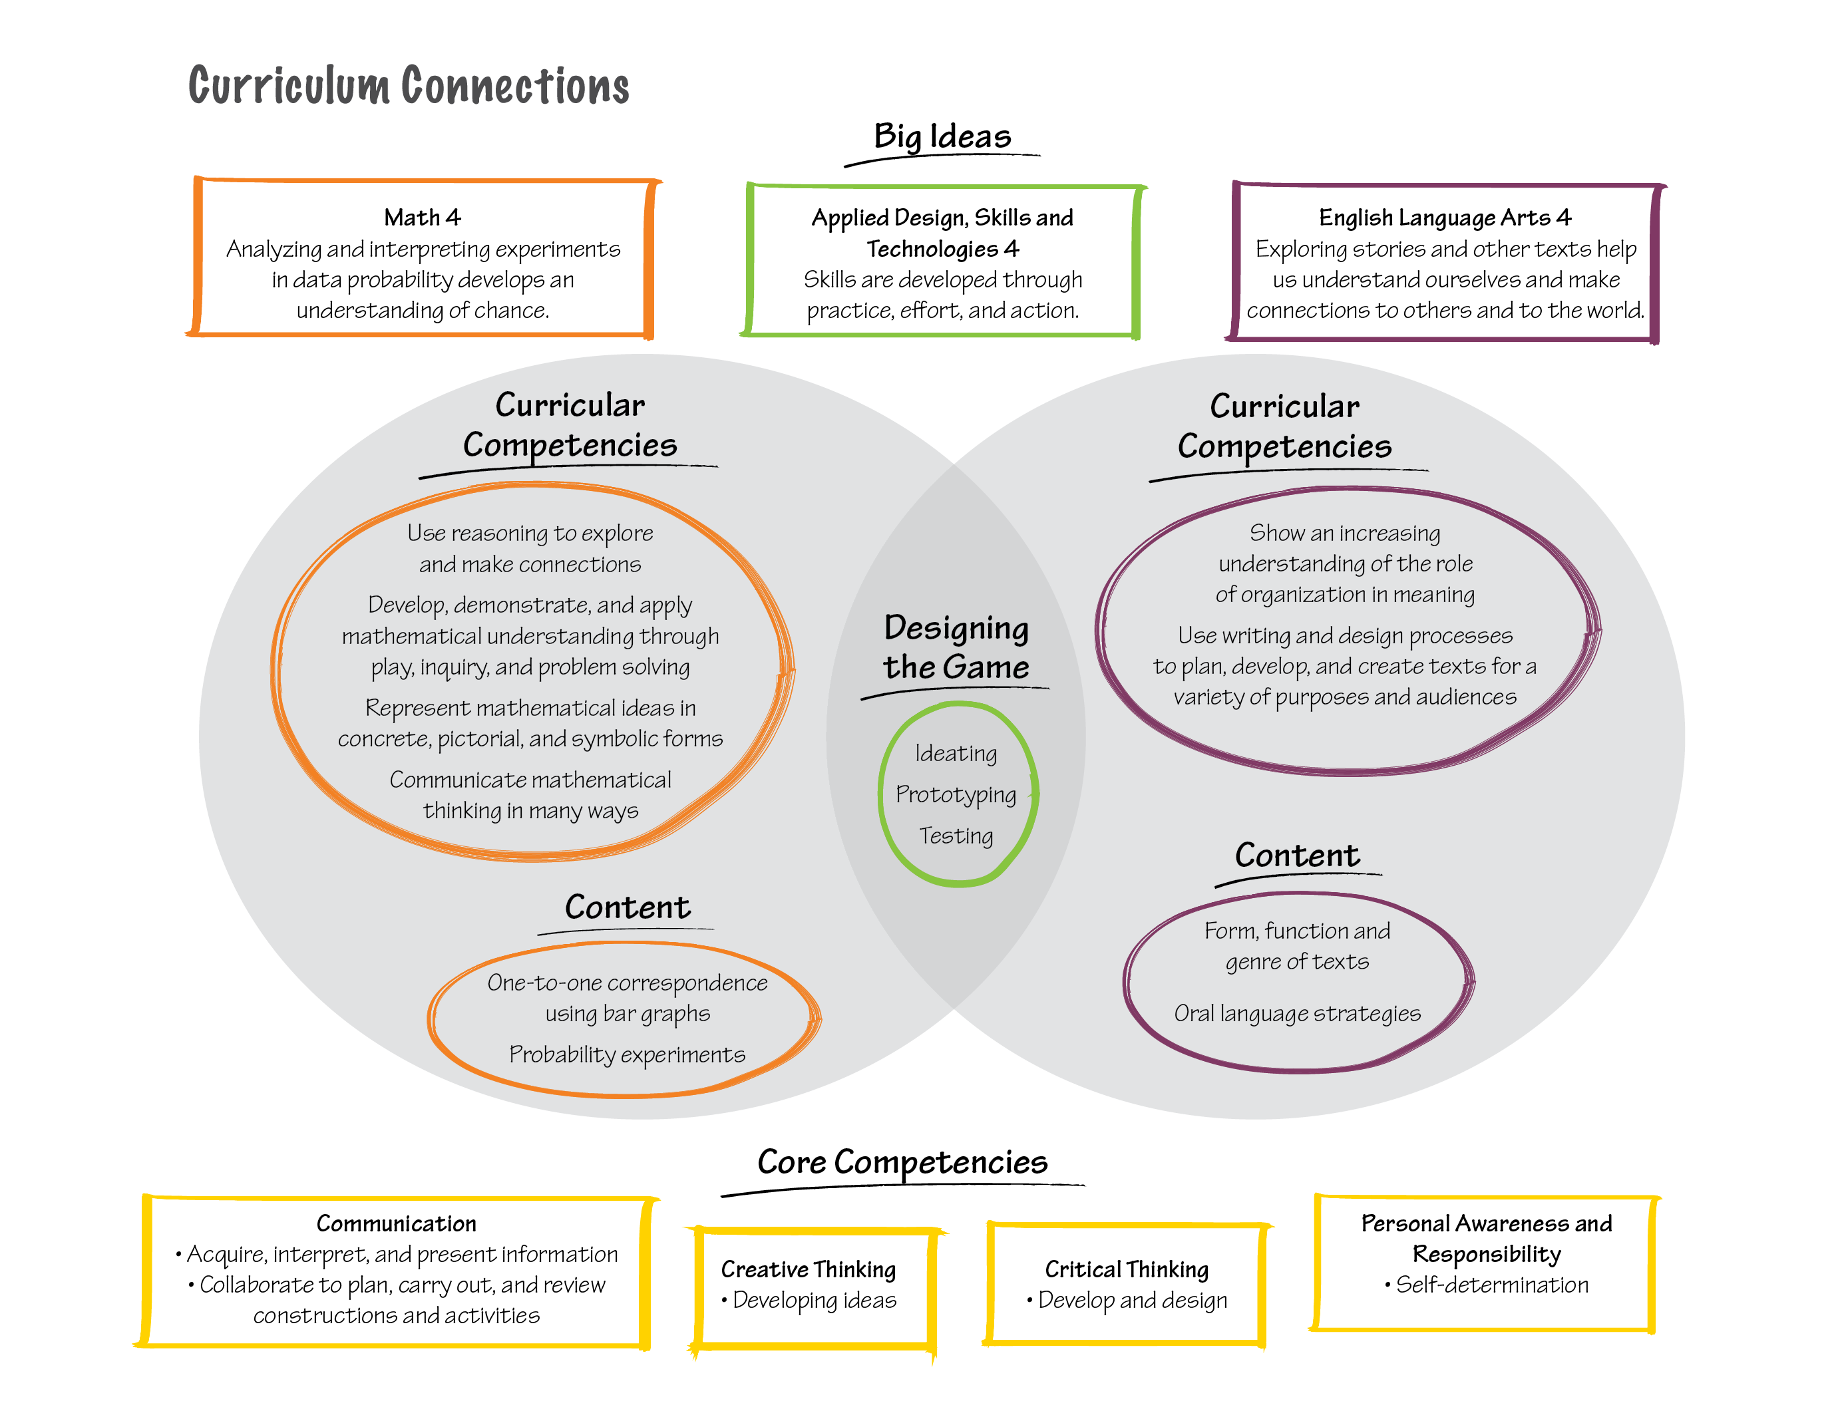

Big Ideas

Math 4: Analyzing and interpreting experiments in data probability develops an understanding of chance.

English Language Arts 4: Exploring stories and other texts helps us understand ourselves and make connections to others and to the world.

Applied Design, Skills and Technologies 4: Skills are developed through practice, effort, and action.

Curricular Competencies

Math 4
- Use reasoning to explore and make connections
- Develop, demonstrate, and apply mathematical understanding through play, inquiry, and problem solving
- Represent mathematical ideas in concrete, pictorial, and symbolic forms
- Communicate mathematical thinking in many ways

Language Arts 4
- Show an increasing understanding of the role of organization in meaning
- Use writing and design processes to plan, develop, and create texts for a variety of purposes and audiences

Applied Design, Skills and Technologies 4
- Generate potential ideas and add to others’ ideas
- Screen ideas against the objective and constraints
- Construct a first version of the product, making changes to tools, materials, and procedures as needed
- Gather peer feedback and inspiration

Content

Math 4
- One-to-one correspondence and many-to-one correspondence, using bar graphs and pictographs
- Probability experiments

Language Arts 4
- Form, function, and genres of text
- Oral language strategies

Core Competencies
- Communication
  - Acquire, interpret, and present information
  - Collaborate to plan, carry out, and review constructions and activities
- Creative Thinking
  - Developing ideas
- Critical Thinking
  - Develop and design
- Personal Awareness and Responsibility
  - Self-determination

Learning Goals
These goals are a combination of Big Ideas, Curricular Competencies, Content, and the Core Competencies. We developed the goals to be linked to this particular learning activity, and to simplify the curriculum connections. You may choose to use these goals for assessment.

- Use reasoning, logic, play, and inquiry to design and conduct an experiment about probability.
- Create graphical representations to demonstrate understanding of probability concepts.
- Use visual, textual, and oral communication strategies to share and reflect on mathematical thinking and design processes.
- Generate, develop, and test ideas while creating an original game.
- Use text and oral language to convey both information (how to play a game) and a narrative story.
- Work collaboratively and with perseverance throughout a creative process.

Prior Knowledge
In order to understand this lesson, students will need to have prior knowledge of, or will need to review, the following:
- How to construct a bar graph
- Using expressive writing and speaking to convey a message for a specific purpose

Possible Entry Points
We’ve included three entry points here. You can choose to use one or more entry points depending on the learning needs and interests of your students. Each of these activities includes making a graph to explore probability concepts. We chose this approach because it shows probability visually, in a pictorial representation, and from there we can start talking about language and symbols related to probability. In all of these examples, getting the correct answer is not important. The learning occurs in the experimental process.
In these activities, understanding of probability arises naturally as students try to answer the questions. Rather than frontloading the lesson with teacher-talk about probability, we wanted students to discover the need for probability on their own. Mathematical notations and vocabulary can then be introduced as useful tools to describe their findings.

If needed, you should model and/or review how to properly construct a bar graph, including:
- labelled axes
- appropriate title
- appropriate scale
- space between bars

Providing students with grid paper will make graphing easier.

This review of graphing techniques can also serve as a way of introducing the assessment criteria for these activities. Each of these activities can involve both student self-assessment and teacher assessment. For ideas on assessment for the entry points (including questions and rubrics), see Appendix A.

We feel it is important that students have opportunities to practise making bar graphs before an evaluative teacher assessment. Therefore, one of the entry point activities could be used for practice (with formative assessment provided orally) and another could be used for summative assessment.

Activity 1: What’s in the Bag
A note about assessment: We’ve included three types of assessment in this learning activity:
1. Teacher observation of process
2. Student self-assessment of products and process
3. Teacher assessment of products
As students are working in their small groups, you can observe, take notes, and ask questions. This will provide valuable information with which to assess not just the product of students’ learning, but the process they used to arrive there.
- To begin, divide students into pairs and give each pair a paper bag containing the same combination of 10 coloured square tiles (e.g., 1 blue, 2 yellow, 2 green, 4 red, 1 orange) and tell students that each bag has the same combination of 10 tiles.
- Ask students to think about how they could determine what the colours of each of the tiles are if they are only allowed to draw one tile at a time from the bag. Have them brainstorm solutions.
- Most students will realize that they should record the colour of each tile they draw and repeat this many times. Suggest that they use tallies and then make a bar graph with their results, or record their results straight onto a bar graph.
- Students can use their graphs to make predictions about how many tiles of each colour are in their bag.
- When ready, compile the results from each group. Invite students to compare their results with the results from the whole class. Ask: Which is more likely to be closer to the true result? We want to get at the idea that the more trials we do, the more statistically likely we will be to get the true result.
To get students thinking about probability, you may want to ask students questions like:
- Which colours of tile(s) are more/less likely to be drawn from the bag than the green tile?
- What colour of tile is impossible to draw?
- What colour of tile are you certain to draw?
- This is a natural time to discuss various ways to express probability — for example: P(green) = 2/10 = 0.2. Students readily accept this notation as a shortcut to writing out “probability of.”
- Ask: What conclusions can you draw, and what evidence do you have for those conclusions? Language to build as students make predictions and conclusions includes:
  - “less likely”
  - “equally likely”
  - “more likely”
  - “impossible”
  - “certain”
- The final step is for students to look in the bags to verify their results.

Activity 2: Help Martha Speak
- Read or tell the story of Martha the dog, from the book Martha Blah Blah, by Susan Meddaugh.
- If you choose to tell the story without the book, here is a brief description: “There is a dog named Martha who is able to speak when she eats the letters in alphabet soup. The letters Martha eats are the letters she can use to speak. One day, the soup company’s owner removes some letters from the soup to save money. Martha has difficulty speaking because certain letters are missing from her soup and therefore she can no longer use those letters to form words.”
- Ask students to discuss the following questions: Which letters should the company remove to have the least effect on Martha’s speech? Which letters will have the greatest effect on Martha’s speech? How can we design an experiment to answer these questions?
- In order to answer these questions, students will likely conclude that they need to gather data about the frequency with which each letter is used in the English language. To do this, they can use texts from their own writing (if there aren’t too many spelling mistakes), from a page in a book, or from lists of the most commonly used words in the English language. You should have these resources on hand for students to use, and you may want to model how to determine letter frequency by counting the number of times each letter appears in a text.
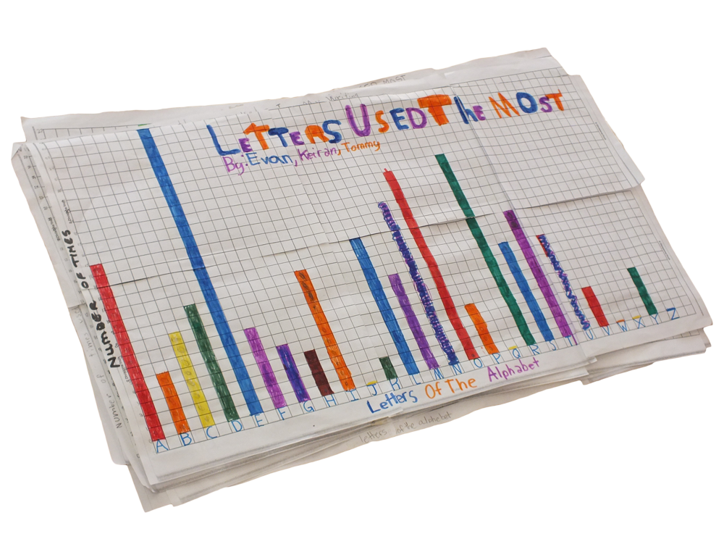
- Students can record how many times each letter appears directly onto a bar graph, or onto a tally sheet which they will then convert into a bar graph.
- When students are done, ask them to draw conclusions from their results. Again, encourage them to use the terms “less likely,” “equally likely,” “more likely,” “impossible,” “certain.”
- They can then check the accuracy of their answers using Wikipedia’s entry on Letter Frequency.

Activity 3: Restaurant Toys
- Start with a story like this: “A local restaurant gives out a toy with each kids meal. There are six different awesome toys and you’re randomly given one at each visit. You can’t exchange toys or request toys. You get what you get and you don’t get upset. A bewildered mother approaches you, because she knows what a great mathematician you are, and she wants to know this: “About how many kids’ meals do I have to order to get at least one of each toy?” What experiment could you design to answer her question?
Students may come up with valid alternatives to using a die, such as a spinner split into six equal parts. It’s also important to discuss why some possibilities won’t work (such as six different-sized objects in a bag).
- As a class, discuss experiment options. If using a six-sided die doesn’t come up, suggest it.
- Students roll a six-sided die and record which number they get with each roll, keeping track of how many times they had to roll to get all six numbers. They can repeat this several times. After students have done this activity for a little while, ask them to stop rolling the die and draw some conclusions about their data. They should draw conclusions based on their own data and on data from the class as a whole.
- As a class, discuss:
  - What would you tell the person who wants to get each toy? Is it the number that came up most frequently, the highest number, the lowest number?
  - Is there a “right” answer to this question?
  - How many times should you do the experiment?
- The goal is for students to understand that more experiments lead to more accurate predictions.

Creating a Game

The entry points should give students a solid understanding of probability and how it applies to real-world situations. Now it’s time to build on that understanding by creating a game of chance. Before having them their own game, engage the class in a discussion about games they’ve played. You can suggest examples of games if students do not come up with them on their own.

You can ask questions like:
- What is the difference between a game of chance and a game of strategy? What are some examples?
- What games have you played before that involve chance? How are they similar to each other? How do they differ from each other?
- What materials are used in a game of chance? (For example, dice, spinners, cards, drawing from a bag. If possible, connect this conversation to the entry point activities.)
- Can you think of some examples of games that are based on stories? How do stories help us understand and connect to games?
- What makes a good game? What makes it fair? What makes it fun?

You might want to suggest that a fair game of chance is one that uses some randomizing device (such as dice, a spinner, a roulette wheel, drawing cards, or items from a container) to ensure that every player is “equally likely” to win (or lose).

With the whole class, have students develop assessment criteria for their games as an outcome of this conversation. For ideas, see the rubric and questions provided in Appendix B.

Divide students into pairs and invite them to create a game of chance using the following criteria:
- They must design a fair game of chance where it is possible to win often enough to keep players engaged.
We put students in pairs because we feel that co-operation is an integral aspect of the learning activity. Working in pairs gives students opportunities for personal and social learning and building on each other’s ideas. We prefer pairs to groups of three or four because there won’t be a chance that someone could be left out.

- They must link their game to a story of their own creation that naturally leads into a game of chance (such as the examples already discussed in the “Help Martha Speak” and “Restaurant Toys” activities).
- They must provide a clear, written set of rules that another classmate could easily follow without having to ask questions.
- They will be required to present their stories and games to their classmates.

These criteria were selected not only to make sure that math and language arts concepts were addressed but also to stimulate creativity. For example, we decided not to ask that the results be graphable, as this could place limits on game design. You may choose to require a graphing component if you feel your students need more practice in graphing. If you want to simplify the activity, you can also add more constraints; otherwise students may want to make a very elaborate game using a combination of spinners, dice, cards, and so on.

An important First People’s Principle of Learning is that “learning involves patience and time.” We feel it’s important not to rush this process. Allow students time to try things out; play, improve on, or recreate their game; and practise their storytelling until they feel ready to share.
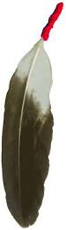
Provide students with the time and materials to create their game. When each group has finished their game, have them present it to the rest of the class. This could be done in a variety of ways — for example, by having them present to the entire class, in small groups, or to one other group. In their presentations they must begin by telling the story of their game, using creative oral expression. They may need to practise this beforehand with each other, experimenting with using intonation, movement, and tone of voice to carry specific meaning, to show excitement, and to create interest. (For more on this, see the suggestion to incorporate First Peoples storytelling methods in the “Extensions” section.)

Students will then play each other’s games, making sure to read the instructions first. After playing, they can provide feedback on the games. It may be useful to introduce and/or review some principles for giving constructive feedback, such as being specific and mentioning both positive aspects and areas to improve upon. You could provide students with some standard feedback questions, such as those listed in Appendix B.

You will need to judge whether your class is ready for giving constructive feedback — if they are not, this final activity could spoil the fun, leaving students with negative feelings. However, if they are ready for this, it will help them to practice peer assessment skills and will provide each group with rich feedback.

Reflection
Have students write “I can” statements about the process and outcome of developing their games. If they are not already familiar with writing these statements, this is a good time to introduce the concept. You can use the examples in Appendix C to demonstrate good “I can” statements. Each statement must be specific, and must be supported with evidence.

Extensions
Students could experiment with using technology to further their learning about probability and graphing. For example, they could do one of the following:
- Use a spreadsheet program to create a graph.
- Play an online probability game, like this game about a random ball machine from Science Kids.
- Watch or listen to First Peoples oral stories and explore with students how storytelling is used in First Peoples culture. Practice storytelling techniques with students and use them when they explain their stories about the game. The following resources may be useful:
- Teaching Storytelling the Classroom — a short video based on the book Children Tell Stories, by Martha Hamilton and Mitch Weiss
- First Nations Pedagogy Online — teacher resources about storytelling and other First Nations approaches to teaching
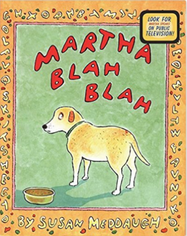

Resources
Martha Blah Blah, Susan Meddaugh,
HMH Books for Young Readers (1998).

Assessment

This learning activity has several different assessment strategies, to provide both formative assessment (assessment for learning) and summative assessment (assessment of learning). You can choose to include all or some of these assessment activities.

Assessment Activity | Curricular Connections
1. Self assessment of bar graphs  (Appendix A) | Math 4 Curricular Competency: Reflect on mathematical thinking
2. Teacher assessment of bar graphs  (Appendix A) | Math 4 Curricular Competencies and Content
3. Self assessment of game (Appendix B) | Math 4, Applied Design 4, Language Arts 4 Curricular Competencies and Content
4. Peer assessment of game (Appendix B) | Math 4 and Applied Design 4 Curricular Competencies and Content
5. Teacher assessment of game and story presentation (Appendix B) | Math 4, Applied Design 4, Language Arts 4 Curricular Competencies and Content
6. Self assessment of learning using “I can” statements (Appendix C) | Core Competencies
7. Teacher observation of process and conversations with students (Appendix D) | Core Competencies and Curricular Competencies

Don’t forget to keep the Big Ideas in mind in your assessment:
- Analyzing and interpreting experiments in data probability develops an understanding of chance.
- Exploring stories and other texts helps us understand ourselves and make connections to others and to the world.
- Skills are developed through practice, effort, and action

Appendix A: Graph Assessment

Self-assessment of graphs
Submit answers and/or evidence for these guiding questions:
- Does your graph contain all the necessary elements of a bar graph?
  - Appropriate title
  - Labelled axes, with units if necessary
  - Appropriate scale (using grid lines)
  - Bars with spaces between them
- What conclusions can you draw from your graph?
- How did using a graph help you figure out the answer?
- What challenges did you face in making your graph? How did you deal with those challenges?
- What was it like to work with a partner on making your graph? How did both you and your partner contribute to the activity?

Teacher assessment of graphs

Assessment Category | Emerging | Developing | Applying | Observation Notes
Appropriate title | The title does not reflect what the data shows, or is missing | The graph contains a title that generally tells what the data shows | The graph contains a title that clearly and specifically tells what the data shows
Axes | Axes are not labelled or labels are not accurate | Axes labels generally correspond to data | Axes are clearly and correctly labelled in correspondence with data
Appropriate scale | Points on the axis are too close together or too far apart | Points on the axis are somewhat logically spaced | There is an evenly spaced and logical distance between points on the axis
Bars have spaces between them | No spaces between bars | Some bars have spaces between them | Adequate spaces between all bars
The graph looks neat and is easy to read | Messiness of the graph interferes with the ability to read it | The graph is somewhat clear and easy to read | The graph is easy to read because writing is clear, colouring is neat, lines are straight

Appendix B: Game Assessment

Self-assessment of games
Submit answers and/or evidence for these guiding questions:
- How well does your story explain your game?
- Is the story creative and engaging?
- Why is your game a game of chance? Can you give examples?
- How do you know your game is fair?
- What makes your game fun? Why would someone want to play your game?
- What did you learn by making this game?
- What challenges did you face in making your game? How did you deal with those challenges?
- What was it like to work with a partner on making your game? How did both you and your partner contribute to the activity?

Peer assessment of games
Provide students with some standard feedback questions, such as:

- Did you have any questions about the game?
- What did you like best about this game? (Be specific!)
- What aspects of the game were the most creative?
- What suggestions do you have for making this game even better?

Teacher assessment of games

Assessment Category | Emerging | Developing | Applying | Observation Notes
Creating and refining game | Students did not improve or refine their game while making it | Students somewhat improved or refined their game while making it | Students tried different approaches and made improvements to create the best game they could
Game is truly a game of chance | Game is not based on chance | Game is based somewhat on chance | Game is based entirely on chance
Game links to story | Game does not link to story | Game is somewhat linked to story | Game is clearly linked to story
Neatness | Messiness of game interferes with ability to play it | Some aspects of the game are neatly done and labels are somewhat clear | Game is neatly put together and clearly labelled
Rules | Rules are unclear | Rules are somewhat clear | Rules are clear and do not require further explanation
Oral story | Oral story was of limited creativity or used limited expression | Oral story was somewhat engaging and creative | Oral story used creative expression to engage listeners
Playing other students’ games | Student did not give constructive feedback to peers | Student gave somewhat constructive feedback to peers | Student gave constructive feedback to peers
Appendix C: “I Can” Statements

Examples from the BC curriculum’s Core Competencies

Communication: Acquire, interpret, and present information (includes inquiries)
  - I can understand and share information about a topic that is important to me
  - I present information clearly and in an organized way

Communication: Collaborate to plan, carry out, and review constructions and activities
  - I can work with others to achieve a common goal; I do my share

Creative Thinking: Developing ideas
  - I make my ideas work or I change what I am doing
  - I can usually make my ideas work within the constraints of a given form, problem, and materials if I keep playing with them
  - I build the skills I need to make my ideas work, and usually succeed, even if it takes a few tries

Critical Thinking: Develop and design
  - I can experiment with different ways of doing things
  - I can develop criteria for evaluating design options
  - I can monitor my progress and adjust my actions to make sure I achieve what I want

Personal Awareness and Responsibility: Self-determination
  - I can show a sense of accomplishment and joy
  - I can celebrate my efforts and accomplishments
  - I can advocate for myself and my ideas

Examples of “I can” statements with evidence

- I can work with others to achieve a common goal: I do my share. Evidence: My group made a game and I helped make the game and I wrote some of the rules. I also presented with my partner.

- I can make my ideas work or I change what I am doing. Evidence: Our first game didn’t work because it was too hard to win, so we changed the rules to make it easier.

- I can advocate for myself and my ideas. Evidence: I really wanted our game to use dice. I told my partner why dice would work the best. Now our game uses dice. I had a good idea.

- I can experiment with different ways of doing things. Evidence: Our group tried a lot of ideas before we decided on the game we made.

- I can identify problems and compare potential problem-solving strategies. Evidence: Our group made a game that used a spinner, but it didn’t work because it was too easy. So then we thought about different ideas and decided to use a 10-sided die.

Actual student-written statements from the Help Martha Blah Blah Speak activity

- I can gather information to tell you and everyone else which letters are commonly used. I can organize this information in a way that’s easy to recognize. I can work with a partner to produce a finished product.

- I can gather evidence to make a bar graph to show what letters are used most commonly.

- I can combine and gather information to create a bar graph. I can now read a bar graph.

- I can use data to make a bar graph that shows the most used letters in our words. E was the letter that was used most often, which surprised me. J, q, x, z and v were used the least.

Appendix D: Teacher Observation and Conversation Prompts

This learning activity uses multiple methods of assessment, including assessment through products, observations, and conversations. Information from observations and conversations is not intended to be rated (as in a rubric), but instead to add another type of evidence for student learning.

While students are working in groups, teachers can observe their work and/or ask students questions to determine the extent to which they demonstrate evidence of the following curricular and core competencies. Teachers can make notes about student learning to inform their assessment process. Teachers can choose which of the following competencies to address through observations/conversation:

- Using reasoning and logic to explore and make connections

- Developing, constructing, and applying mathematical understanding through role-play, inquiry, and problem solving

- Describing, creating, and interpreting relationships through concrete, pictorial, and symbolic representations

- Sharing and reflecting on mathematical thinking

- Showing an increasing understanding of the role of organization in meaning

- Using writing and design processes to plan, develop, and create texts for a variety of purposes and audiences

- Using the skills of ideating, prototyping, and testing

- Acquiring, interpreting, and presenting information

- Collaborating to plan, carry out, and review constructions and activities

- Developing ideas and using them to create designs

- Exhibiting self-determination

