The BIG Mathematical Idea — Grade 2
Students will know and understand:
The regular change in increasing patterns can be identified and used to make generalizations.

Inquiry Question: What is the pattern rule you used to create your increasing pattern? How would you describe it?

Curricular Competencies  Students are expected to be able to DO the following: | Content  Students are expected to KNOW the following:
Reasoning and analyzing  - Use reasoning to explore and make connections  Understanding and solving  - Develop, demonstrate, and apply mathematical understanding through play, inquiry, and problem solving  - Develop and use multiple strategies to engage in problem solving  Communicating and representing  - Communicate mathematical thinking in many ways  - Use mathematical vocabulary and language to contribute to mathematical discussions  - Explain and justify mathematical ideas and decisions  - Represent mathematical ideas in concrete, pictorial, and symbolic forms  Connecting and reflecting  - Reflect on mathematical thinking  - Connect mathematical concepts to each other and to other areas and personal interests | • Repeating and increasing patterns

Description of Learning Activity
We use patterns to represent identified regularities and to make generalizations. This lesson extends patterning concepts taught in Kindergarten and Grade 1, where students learned to identify and extend patterns with multiple attributes. It is essential for students to describe, extend, and make generalizations about patterns that seem to be the same or different. This kind of categorizing and generalizing is an important developmental step on the journey toward algebraic thinking. To build a strong foundation of skills, every student should be able to show and communicate their understanding of the concepts, and be allowed to represent their understanding through concrete materials, pictures, numbers, or words. Providing the opportunities for students to show what they know in a way that makes sense to them is a critical component of this learning experience. Ensure that the required manipulatives and “thinking tools” are accessible. Consider some guiding questions you might ask to scaffold or extend thinking.

Before
- Read and discuss a picture book focused on pattern, such as Spotty, Stripy, Swirly, by Jan Brocket.
- Identify patterns, non-patterns, and increasing patterns represented in the book.
- Begin with a 1st element and ask students to model how it might grow.
- Identify the elements as the pattern increases.
- Record some of the patterns, using manipulatives, drawings, letters, or numbers.
- Ask the students to identify the pattern rule and the elements as the pattern increases, and explain their reasoning.
- Create and extend increasing patterns together using two or more elements and attributes.

During
- Read aloud the Inquiry Question and ask the students to discuss how they might approach this question.
- Once the students have heard several strategies, ask the students choose whether to work individually, in pairs, or in small groups to explore the questions.
- Make concrete materials available, such as counters, pattern blocks, or buttons, for students to use.
- Ask the students to record the patterns they have created (e.g., photos, drawings, stamps).
- Circulate, assist students, and ask prompting questions as needed.

After
- Gather the students together to share their discoveries.
- Ask the students to show and explain how they represented the increasing patterns.
- Ask: How do you know you have an increasing pattern? (It is growing; there are more counters in each element; there is a pattern in the way it goes.)
- Ask the students to explain how they identified the pattern rule and how the elements increase.

Considerations

First Peoples Principles of Learning: Revisiting concepts multiple times, providing learners with opportunities to deepen their knowledge by layering their understanding. (Learning involves patience and time.)

Adaptations: Students who have difficulty with creating an increasing pattern may need more opportunities to develop their understanding of pattern and the pattern core. They may need more scaffolding in creating an increasing pattern by starting with a simplistic first element that you can model and work together to have it increase.

Extensions: For an extra challenge, encourage students to use multiple attributes (e.g., colour and shape) to make more complex increasing patterns. Another possibility would be to change the initial pattern into a different increasing pattern.

Assessment of Learning
Demonstrating understanding of Content through the Curricular Competencies
Choose one or more of the following to assess, depending on the context of your class:
Curricular Competencies  Students are expected to be able to do the following: | Questions to ask to uncover the knowing and understanding:
Reasoning and analyzing  - Use reasoning to explore and make connections | - How do you know the pattern is increasing?  - Explain your reasoning.
Understanding and solving  - Develop, demonstrate, and apply mathematical understanding through play, inquiry, and problem solving  - Develop and use multiple strategies to engage in problem solving | - What strategies did you use to create the increasing pattern?  - Describe and compare strategies you used to represent the increasing pattern you created.
Communicating and representing  - Communicate mathematical thinking in many ways  - Use mathematical vocabulary and language to contribute to mathematical discussions  - Explain and justify mathematical ideas and decisions  - Represent mathematical ideas in concrete, pictorial, and symbolic forms | - How would you express and describe the increasing pattern?  - How would you interpret relationships through various representations?  - Explain how you used technology to communicate and represent you thinking.
Connecting and reflecting  - Reflect on mathematical thinking  - Connect mathematical concepts to each other and to other areas and personal interests | - Explain how you visualized and proved the pattern increases.  - How did visualizing help you?  - What connections did you make?  - Reflect and identify the relationships represented.

Student Samples
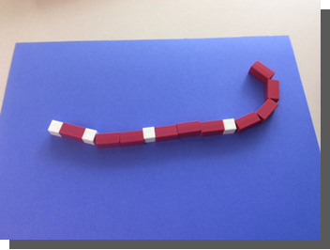
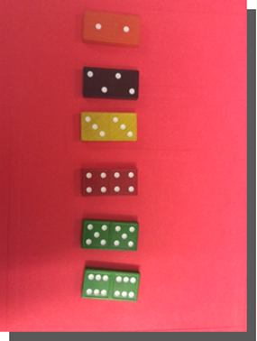
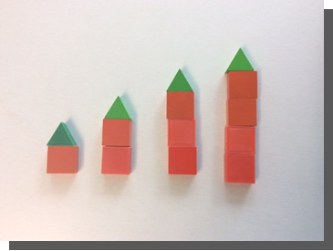

What Next?

- Reflecting on the activity, how might you support or extend students’ understanding?
- Do some of the students need more opportunities to explore this concept?
- What were some common misconceptions?
- Which materials did the students use to build understanding?
- What happens next?
- How would you interpret the information you observed?

Contributed by Sandra Ball

