K-7 Place-Based Mathematics

Teachers and students at Richmond elementary schools, including Lord Byng and Tomekichi Homma, have been examining how mathematics can be experienced in the community, and connecting with stories of place. Inspired by the book Tluuwaay Waadluxan Mathematical Adventures, created by Elders, educators, community members, and students in Haida Gwaii, the Richmond teachers and students have looked for mathematics in their community and posed and solved problems of interest to them.
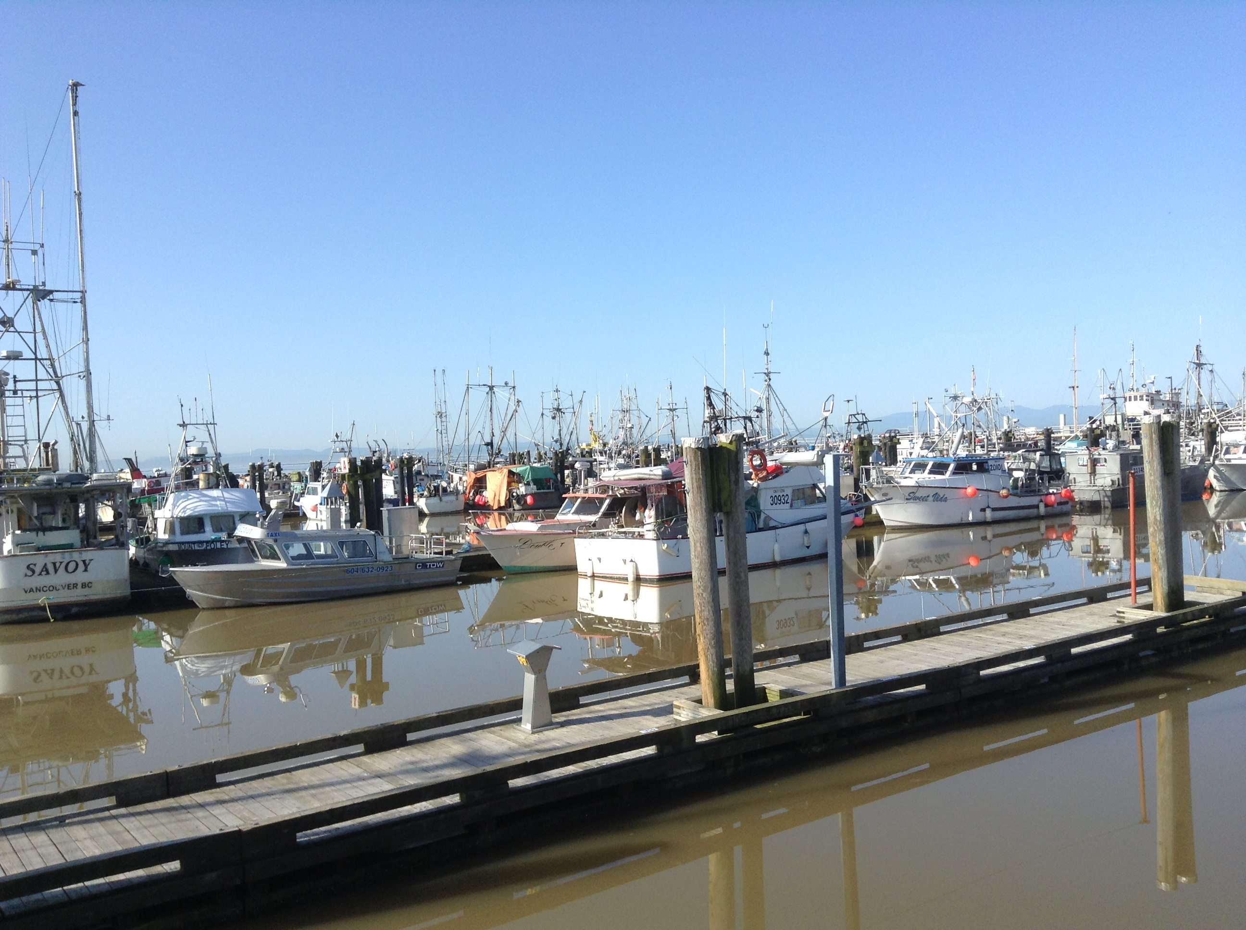
On outdoor “math walks,” the students began by noticing and naming things that made them think of mathematics, and thinking about how mathematics might be experienced outside the classroom. A Grade 1 class chose to focus on looking for 2D shapes and 3D objects in their neighbourhood and compared, discussed, and asked questions about what they noticed. Students in Grades 4 and 5 had many questions about local businesses and their hours of operation, taking photographs of the signage in their windows.
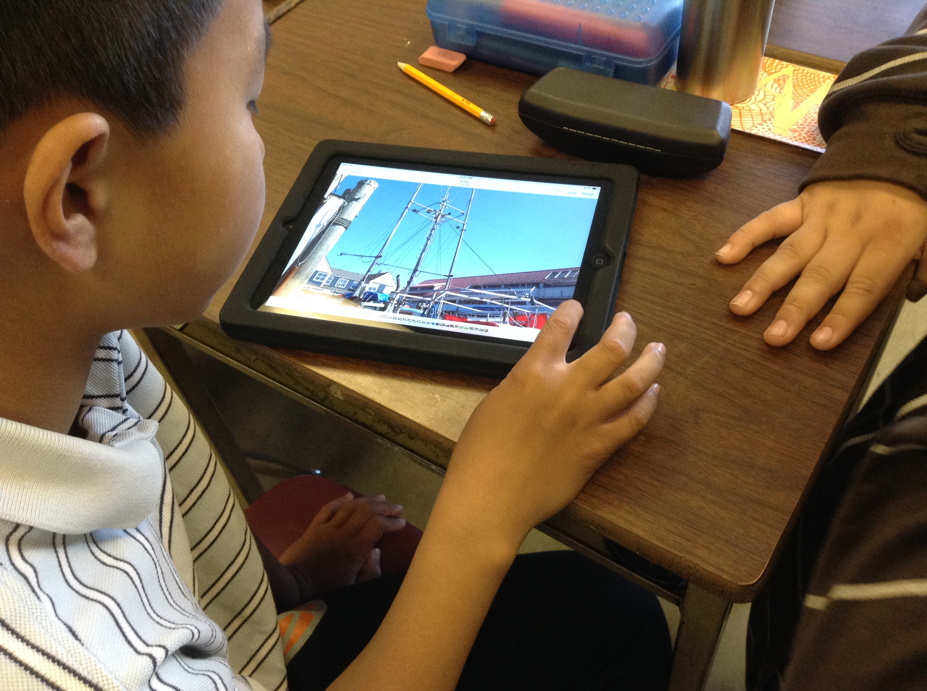
Students then went deeper, asking questions and wondering about how mathematics might help them answer their questions. For example, they used the photographs they had taken with iPads while outside for collaborative discussions that inspired different ways of looking at the same thing and seeing place through a mathematical lens.

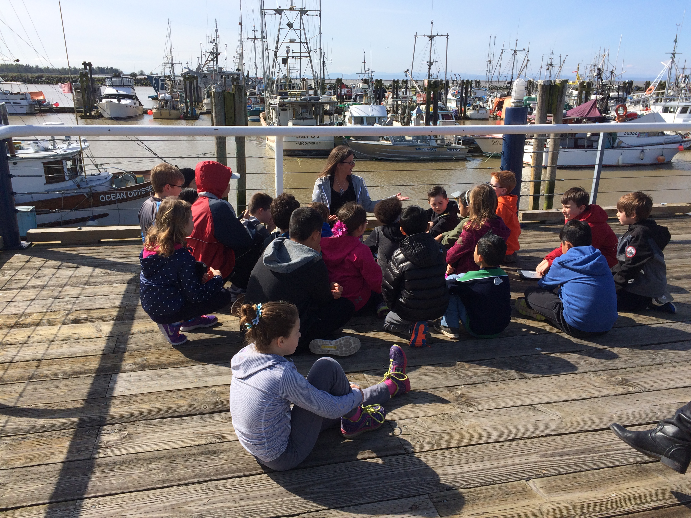
Another learning intention has been for students to feel a strong connection to place and to understand the shared history of this place that is now their home. For example, the students have wondered about the river and what it might have been like thousands of years ago. Inquiry questions emerging from this project included:
- Has the width and depth of the river changed over time?
- How are tides measured?
- How many salmon are caught each year?
- How do fishers know where to find the fish?
These questions led to students investigating current fishing methods and developing an understanding of traditional indigenous knowledge. Through this inquiry, students applied mathematical competencies and used their knowledge of mathematical concepts and content.

Core Competencies: Communication (acquire, interpret, and present information), Social Responsibility (contributing to community and caring for the environment)

Big Ideas: drawn from Mathematics, Science, Social Studies (these vary and depend on grade levels of students and their inquiry questions)

Inquiry question: Where does math live in this place? (the question that frames the overall experience)

Curricular Competencies: Engage in problem-solving experiences that are connected to place, story, cultural practices, and perspectives relevant to local First Peoples communities, the local community, and other cultures (Mathematics)

Content: varies, depending on context and grades. (In the examples mentioned above, Grade 1 students compared 2D shapes and 3D objects in the environment, and Grade 4 and 5 students investigated telling time and measuring duration of time.)

