Instructional Sample: Sense of Place

Rationale
This unit uses diverse written and visual texts to help students understand aspects of who they are by exploring other people’s experiences and perspectives. Students have opportunities to understand how they’re connected to the land and to consider their sense of place. Students analyze and synthesize written and visual texts to inform and inspire the creation of their own written and visual texts.

Grade level/subject
This unit can be adapted to suit Literary Studies 10 and 11, Spoken Language 10 and 11, or English Studies 12; it is up to the teacher to adapt the unit as needed. The learning experiences described here are for Literary Studies 10, for the purposes of providing an example.

Learning standards

Big Ideas
- The exploration of text and story deepens our understanding of diverse complex ideas about identity, others, and the world.
- Texts are socially, culturally, geographically, and historically constructed.

Curricular Competencies

Comprehend and connect
- Think critically, creatively, and reflectively to explore ideas within, between, and beyond texts
- Recognize personal, social, and cultural contexts, as well as values and perspectives in texts
- Recognize and appreciate the influence of land/place in First Peoples and other Canadian texts
- Construct meaningful personal connections between self, text, and world

Create and communicate
- Respond to text in personal, creative, and critical ways
- Use writing and design processes to plan, develop, and create engaging and meaningful texts for a variety of purposes and audiences

Core Competencies

Communication
- Connect and engage with others
- Acquire, interpret, and present information
- Collaborate to plan, carry out, and review constructions and activities
- Explain/recount and reflect on experience and accomplishments

Creative Thinking
- Developing ideas

Critical Thinking
- Analyze and critique
- Develop and design

Positive Personal and Cultural Identity
- Relationship and cultural contexts
- Personal strengths and abilities

Social Responsibility
- Valuing diversity

Guiding inquiry questions
- How does our environment influence who we become?
- In what ways does the natural world reflect human experience?
- What is home?

The learning experience
Each of the steps in the learning experience documented below can be taught as individual lessons or as connected components of a larger unit.

1. Introduction to The Glass Castle
The primary text on which the unit is based is the memoir The Glass Castle, by Jeanette Walls. I have always loved the book and wanted to integrate it into senior classrooms, as I felt it would be engaging for students. The memoir also serves as a smooth transition from the previous unit of study, in which, primarily through short stories, students explored the concept that adversity can be a blessing, a theme that also emerges in The Glass Castle.

If The Glass Castle is unavailable, another option is to read selected excerpts during a class gallery walk, in which students visit stations set up around the classroom. At each station, the students may be asked to complete a learning task. I used a Drive/Tow chart, shown below. In the “Drive” column, students attempt to answer the questions on the relevant excerpt independently. “Tip” envelopes are available for those students who need a “tow.” Students add any thoughts gained from the tip envelopes into the “Tow” column.

The Glass Castle  Excerpt # ______  Excerpt title: _________  _____________________ | In this column, answer the questions to the best of your ability on your own. You are in the DRIVER’S SEAT. | 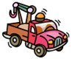 In this column, use the hints provided to add to your answers. You are getting a bit of a TOW.
1) How do you explain the behaviour of the characters?  2) What motivates them or acts as a catalyst to their behaviour?  3) What can we learn from the children in the excerpt?  4) Write a theme. | _________________________  _________________________  _________________________  _________________________  _________________________  _________________________  _________________________  _________________________  _________________________  _________________________ | _________________________  _________________________  _________________________  _________________________  _________________________  _________________________  _________________________  _________________________  _________________________  _________________________

2. Challenging bias on homelessness
In The Glass Castle, Jeanette Walls recalls her nomadic childhood. Her family was often on the move. They lived in abandoned buildings for periods of time and they never owned a house of their own.

I wanted to challenge the students’ thinking about what it means to be homeless. I had them read an essay titled “Homeless,” in which author by Anna Quindlen exposes common biases about homelessness and provokes further thinking. After reading the essay, students engaged in a think-pair-share on the following question:

Question/Prompt | What I think | What my partner thinks | What we will share
According to the definition of homeless provided in this essay, was Jeanette Walls homeless?

Why or why not?
If a class hasn’t read The Glass Castle, the question could be adjusted to read, “What defines a person as homeless?”

Discussion led students to realize that being homeless doesn’t necessarily mean one doesn’t have a house, but that being homeless means one doesn’t have a connection to place or a sense of belonging to a physical location.

I then had students read an informational text (https://www.nwei.org/enjoying-sense-place/) on the meaning of “sense of place” and do a cloze activity, in which they completed sentence starters:

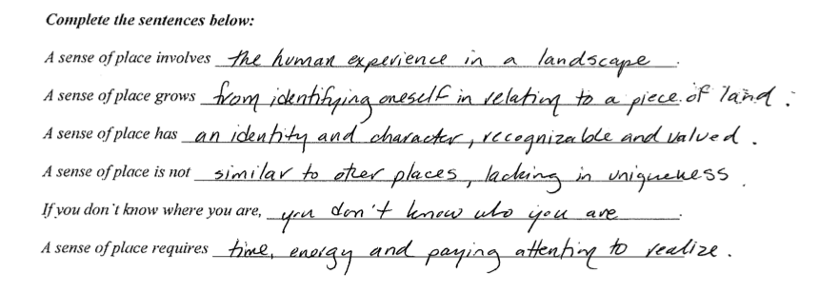
An interesting extension activity could be an investigation into “homelessness” in B.C. Students might look at statistics and counts and consider the diversity of people represented and the challenges and factors that led to their situations. Listening to the stories of some “homeless” people might reveal that in fact they are not homeless but are, instead, lacking a house. Students may then engage in some form of advocacy or social justice initiative, such as collecting canned goods to donate to the food bank, serving meals at a local shelter, or creating a mental health awareness campaign at school.

3. Our connection to the natural world
At one point in The Glass Castle, Jeannette Walls writes:

One time I saw a tiny Joshua tree sapling growing not too far from the old tree. I wanted to dig it up and replant it near our house. I told Mom that I would protect it from the wind and water it every day so that it could grow nice and tall and straight. Mom frowned at me. “You'd be destroying what makes it special,” she said. “It's the Joshua tree’s struggle that gives it its beauty.”

I had students discuss the significance of the Joshua tree to Walls, which led them to understand that the tree was a reflection of her own experiences.

We then read the poem “The Same as Trees,” by Nicola Campbell. It expresses the enduring suffering and loss that are the consequences of residential schools. Campbell’s speaker suggests that hope for healing lies in the wisdom of the Elders, whose traditions parallel the strength of the roots of trees. The speaker also claims that growth and healing are reminiscent of the branches of trees, extending upward.

Students then completed a Venn diagram and wrote a compare-and-contrast thesis statement on these two texts on the relationship between humanity and the natural world. In a synthesis writing piece, students expressed their understanding of the ways in which the natural world reflects human experience.

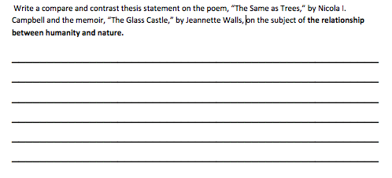
The thesis statements were assessed using the following rubric:
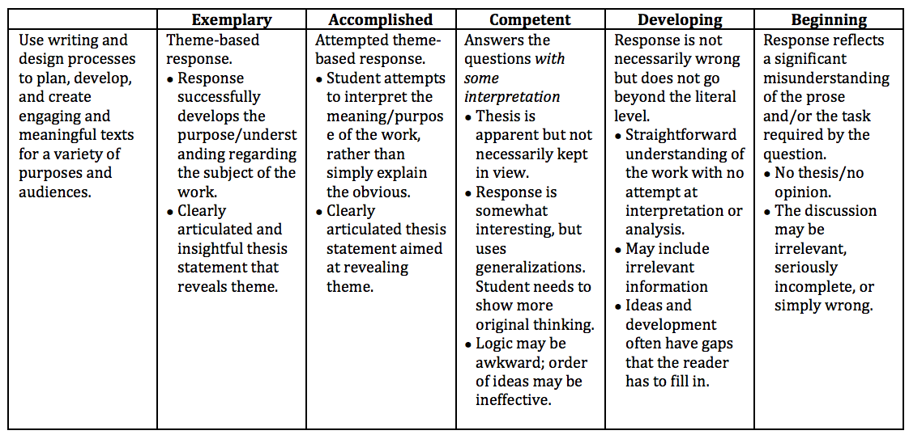

Next, students read the poem “The Cedar Tree,” by Richard Walker, which exposes readers to the importance of cedar to West Coast First Nations and shows how the trees are both practically and symbolically important.

As a follow-up activity, students were invited to consider their connections with trees and to consider different cultures’ symbolic and practical understandings of different trees. They did a “sort and predict” of images of various trees and descriptors of the local and cultural significance of the trees. Below are the tree images, which I distributed to groups of two to four students.
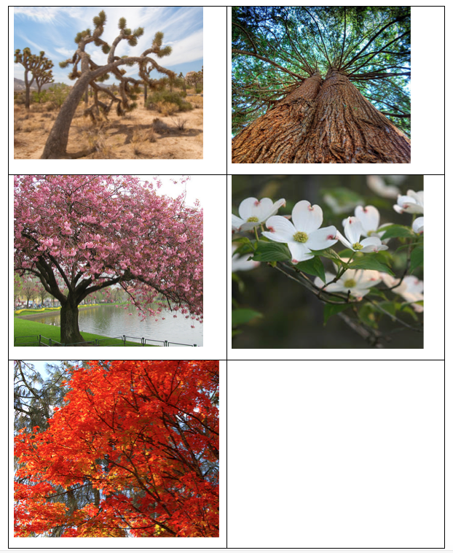

I also distributed the following descriptions of the local and cultural significance of the trees. Like the tree photographs, these had been separated, and students attempted to match the descriptors to the trees.

Tree | Cultural significance/symbolism | Local significance/symbolism
Joshua tree | U2 Album  Name comes from Mormons, who thought the twisted form was reminiscent of Joshua reaching up in prayer. | In The Glass Castle, Jeanette wants to protect the twisted tree, but Rose Mary explains that the struggle with the elements creates the twisted beauty of the tree.  Symbolic of the strength gained from the Walls children’s upbringing, Rex and Rose Mary’s parenting philosophy, and perhaps even Jeanette’s physical burn scars.
Cedar tree | Considered imperishable in Egypt, cedar wood was used to build Solomon’s temple.  A symbol of cleansing and healing in West Coast First Nations.  Used to keep away moths (e.g., valuables stored in cedar chests). | Cedar has ensured the survival of First Nations on the West Coast for thousands of years. It has become a powerful symbol of strength and revitalization and continues to be culturally, spiritually, and economically important.  Emily Carr’s paintings.  The large hollow cedar tree in Stanley Park.  Multiple First Nations have stories that tell of the cedar tree originating from a generous man who was transformed after his death.
Dogwood | Used for healing, dyes, poison, and food in First Nations cultures.  In Christian symbolism, a symbol of the crucifixion. White = purity, red marks = rusty nail marks.  In Victorian times, bachelors sent it to women they were interested in. Women would return flower if they weren’t interested. | Some species indigenous to B.C.  On B.C.’s crest (around motto and royal lion). Became official flower in 1956.  In B.C., dogwood pins were sold to raise money for comforts for soldiers in World War II.
Maple | The maple symbolizes the tree of offering, generosity, balance, promise and practicality. | Symbol of Canada (flag, etc.).  Maple Ridge was named for the maple trees and typography of the McIver farm, where locals decided to form a municipality in 1874.
Cherry | Symbol of the fragility and beauty of life: just like the blossoms, it is brief but overwhelmingly beautiful.  The cherry blossom festival takes place in springtime and is a time for gathering with friends and family underneath the trees (hanami). It originated in Japan but has spread to many other places in the world. | Hundreds of cherry trees have been donated by Japan to symbolize friendship between two countries.  One planted near the memorial to Japanese people mistreated during World War II.  Sakura in Oppenheimer park was planted to commemorate the centenary of Japanese immigrants in Canada and to celebrate their return to the neighbourhood after their forced departure.*
* This activity leads into possible discussions and learning activities centred on the Japanese internment camps.

Connections with First Peoples content and First Peoples Principles of Learning

Learning involves the role of indigenous knowledge.
The poem “The Cedar Tree,” by Richard Walker, exposes readers to the importance of the cedar to West Coast First Nations and shows how the trees are both practically and symbolically important. The follow-up activities invite students to consider their own connections with trees and to consider different cultures’ symbolic and practical understandings of different trees.

The poem “The Same as Trees,” by Nicola Campbell, is about how the current young adult generation of First Nations people find strength from traditional teachings of the ancestors and a better understanding of how to move forward on a path of healing and strength. Students’ follow-up engagement in class discussion and creative pieces can enhance their understanding.

Learning ultimately supports the well-being of the self, the family, the community, the land, the spirits, and the ancestors.
- The poem “The Same as Trees,” by Nicola Campbell, acknowledges the importance of land and place to First Peoples.
- “The Same as Trees” acknowledges the wisdom and significant role of the ancestors in the health and well-being of First Peoples’ communities.
- Students gain an appreciation of the significance of the cedar tree to West Coast First Nations and consider trees that hold local and cultural significance to themselves.

4. The art of Roy Henry Vickers
Roy Henry Vickers is a Canadian artist, born in northern B.C. and currently living in Tofino, B.C. His Indigenous ancestry and his connection with the physical, natural environment inspire his work. I had students read his picture book, The Elders Are Watching.

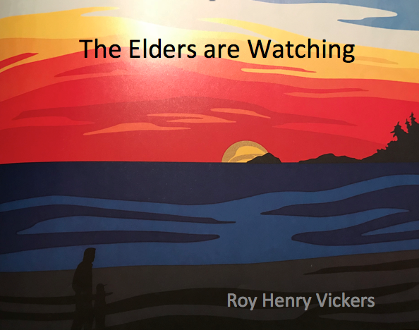
After the reading, class discussion focused on the environmental concerns presented, the possible solutions, the wisdom of the Elders, and the symbolic representation of the message in the colour choices of the accompanying artwork.

Students then viewed a selection of Vickers’s paintings, all of which use similar and consistent colour palettes and elements of composition and incorporate a human presence in a natural landscape.

Inspired by Vickers’s art, students painted their own landscape scene, imitating his colour scheme and brushstrokes and including a silhouette of themselves engaged with the land and connected to place.

Here are two samples of the students’ work:

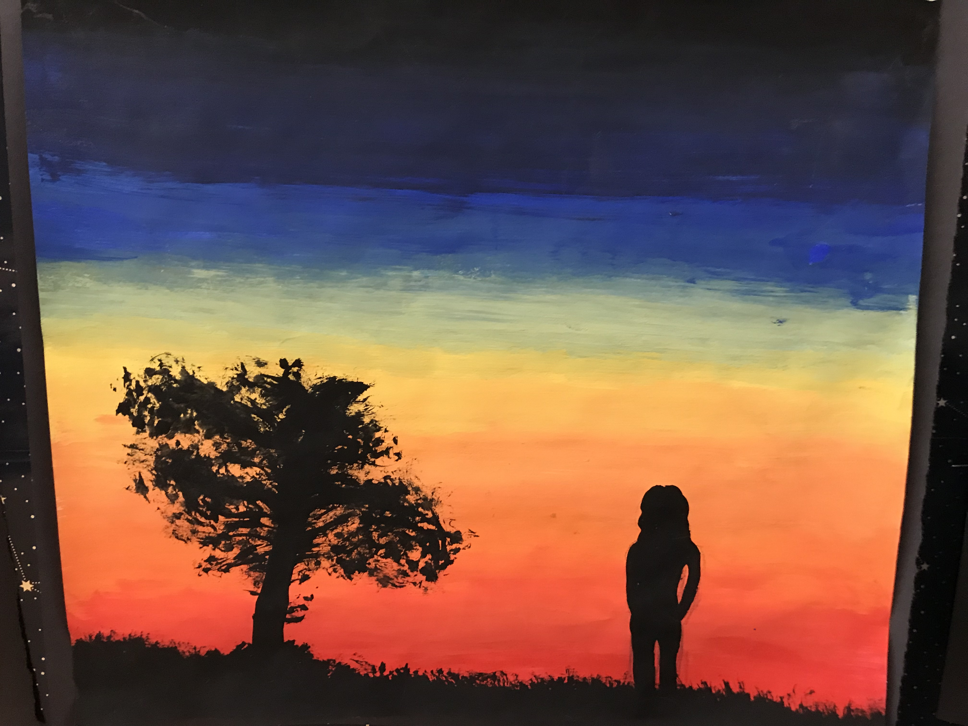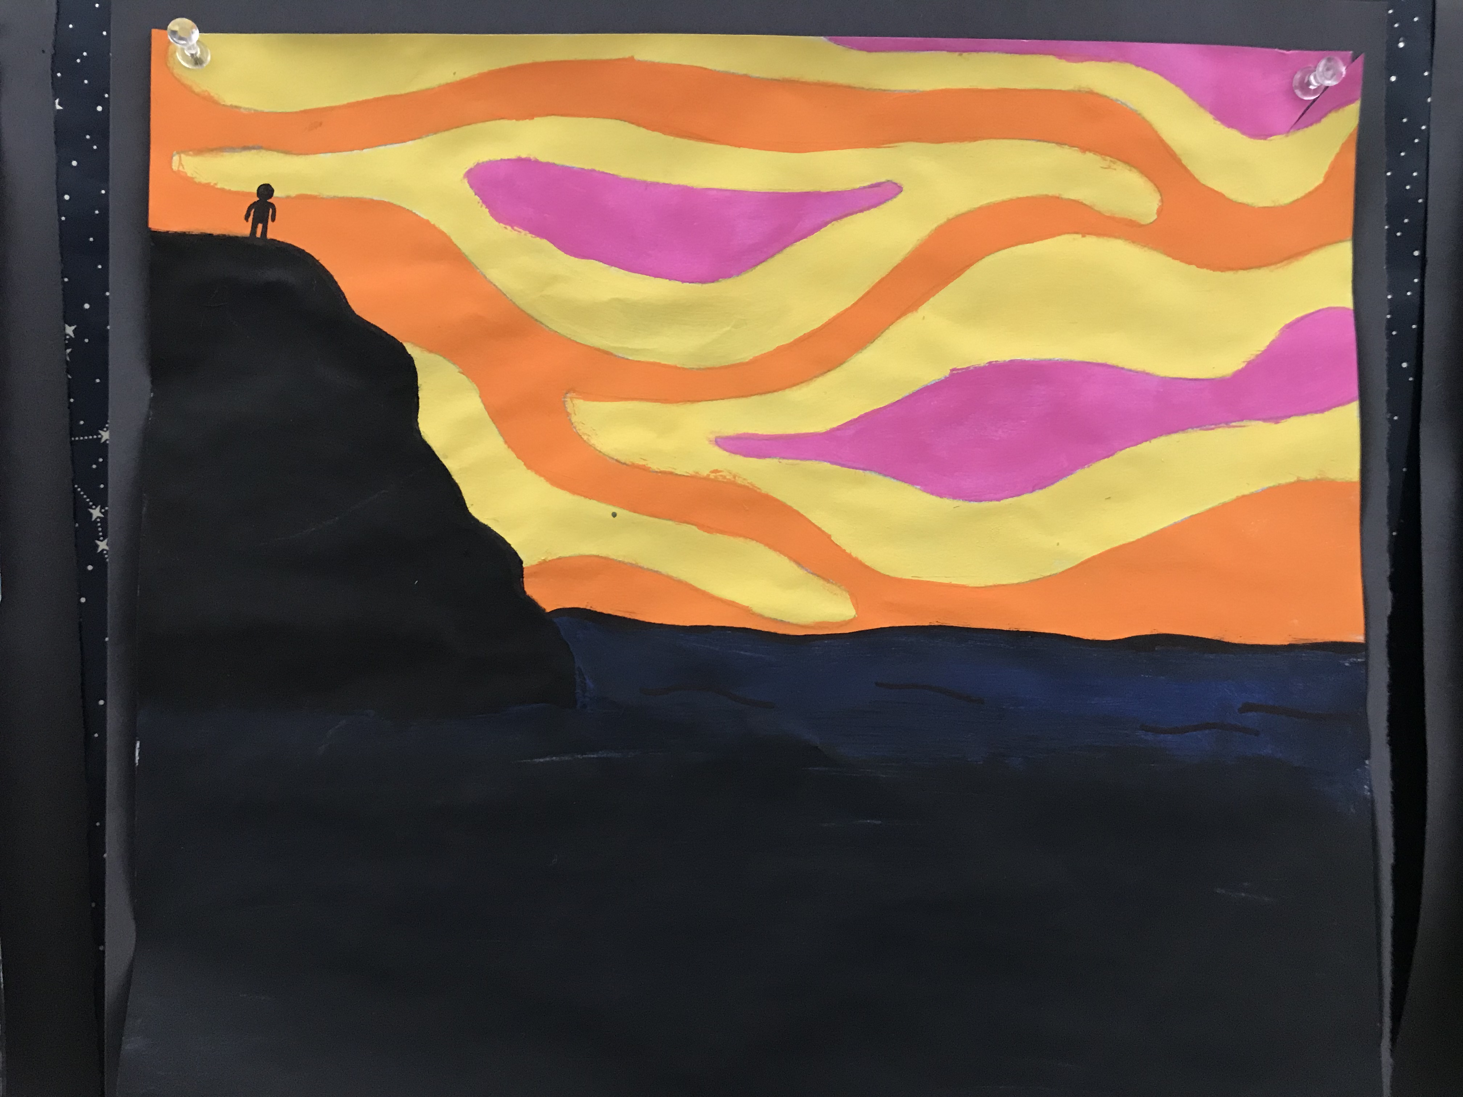

Finally, students wrote artist statements on their pieces, articulating what they had learned about and from First Peoples. They also reflected on and explained their own connection with place. The assessment rubric for this assignment is shown below.

The Elders Are Watching Artist Statement Assessment Criteria: Name: _________________

 | Beginning | Developing | Competent | Accomplished | Exemplary
Recognize and appreciate the influence of land/place in First Peoples’ and other Canadian texts. | Artist statement attempts to recognize that Roy Henry Vickers’s creations are a result of his commitment to his heritage or his environment. | Artist statement clearly recognizes that Roy Henry Vickers’s creations are a result of his commitment to his heritage or his environment. | Artist statement clearly recognizes that Roy Henry Vickers’s creations are a result of his commitment to his heritage and his environment. | Artist statement explains the ways in which Roy Henry Vickers’s text is inspired by his heritage or his environment. | Artist statement explains the ways in which Roy Henry Vickers’s text is inspired by his heritage and environment.
Respond to text in personal, creative, and critical ways | Artist statement provides a limited explanation of the methods used in the art work (choice of colours, brushstrokes, silhouette shape).  The artist’s connection to place or relationship with the environment is unclear. | Artist statement attempts to explain some of the methods used in the art work (choice of colours, brushstrokes, silhouette shape).  Artist statement attempts to explain the artist’s connection to place or relationship with the environment. | Artist statement explains some of the methods used in the art work (choice of colours, brushstrokes, silhouette shape).  Artist statement attempts to explain the artist’s connection to place and relationship with the environment. | Artist statement explains the various methods used in the art work (choice of colours, brushstrokes, silhouette shape).  Artist clearly explains the artist’s connection to place or relationship with the environment. | Artist statement thoroughly explains all the methods used in the art work (choice of colours, brushstrokes, silhouette shape).  Artist statement clearly explains the artist’s connection to place and relationship with the environment.

Connections with First Peoples content and First Peoples Principles of Learning:

Learning involves the role of Indigenous knowledge.
Students read The Elders Are Watching and examine a selection of art by Roy Henry Vickers, to help them understand First Peoples’ connection to land. Students process their learning by developing Roy Henry Vickers–inspired artwork and creating an artist statement to demonstrate what they’ve learned and how they’ve connected it with their personal lives.*

*This includes a class discussion about what is and is not cultural appropriation. Students understood that this activity is not cultural appropriation because the activity helps them process what they are learning about and from First Peoples and is not used for personal gain or to usurp Indigenous voice.

Learning ultimately supports the well-being of the self, the family, the community, the land, the spirits, and the ancestors.
Roy Henry Vickers’s art helps students explore their relationships with place.

5. Sense of place maps
Once students had an understanding of sense of place, I had them begin to create multi-modal and multi-medium maps of “home.” Sara Fanelli’s picture book, My Map Book, provides a nice example of what an abstract map might look like.

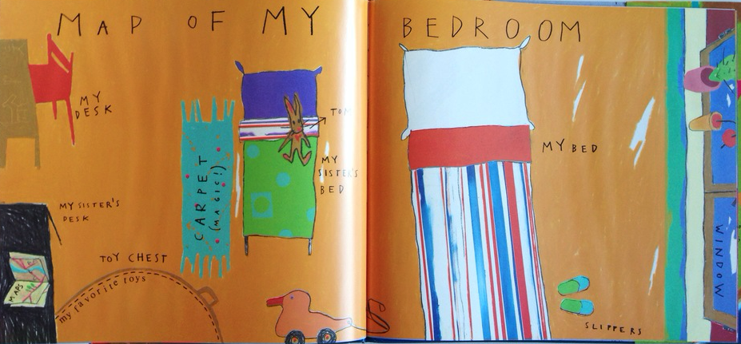

I gave them the following assignment:

Mapping My Place

Using Sara Fanelli’s abstract style of mapping in My Map Book as inspiration, create a map of a place of importance or significance to you. The map does not need to be to scale; instead, larger areas of your map demonstrate the importance of that place to your life. Consider ways to represent the memories, senses, and emotions that you relate to the place.

For example, I might create a map of my childhood family room. The big, oversized brown arm chair would be large because that is where my dad always read us books. The family room was also beside the kitchen, so I might include the delicious smells of dinner wafting through the doorway.

You might make a map of your backyard, the school playground, grandma’s house, or the neighbourhood park.

The foundation of your map will be a piece of cardboard, roughly 12x12 inches. You need to bring a piece of cardboard with you next class.

Your map will be multi-modal. In other words, it will mix print and image. You need to include a title, labels, and at least two flash fiction narratives (stories of less than 100 words). The print on the map can be a combination of:

- handwritten
- typed
- collaged
- stamped

The images will also be created out of multi-media resources such as:

- plastic
- ribbon/string
- metal
- paint, pastels, markers, chalk, crayons
- buttons
- sparkles
- stamps and stickers (scratch ’n’ sniff)
- cotton balls
- sand or gravel
- fabric strips
- newspaper or magazine clippings
- tin foil
- staples
- wire
- 3D elements (e.g.,. pop-up windows, fold-outs)

The finished products were impressive. Below are some samples of the students’ maps:

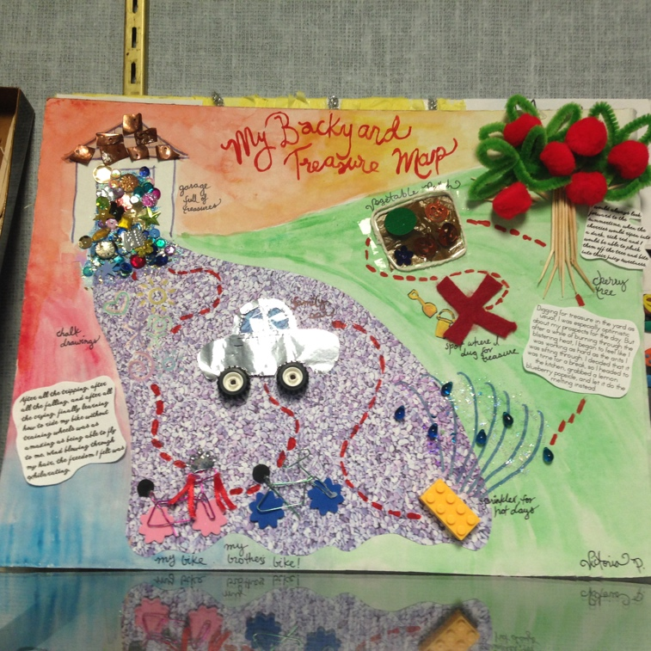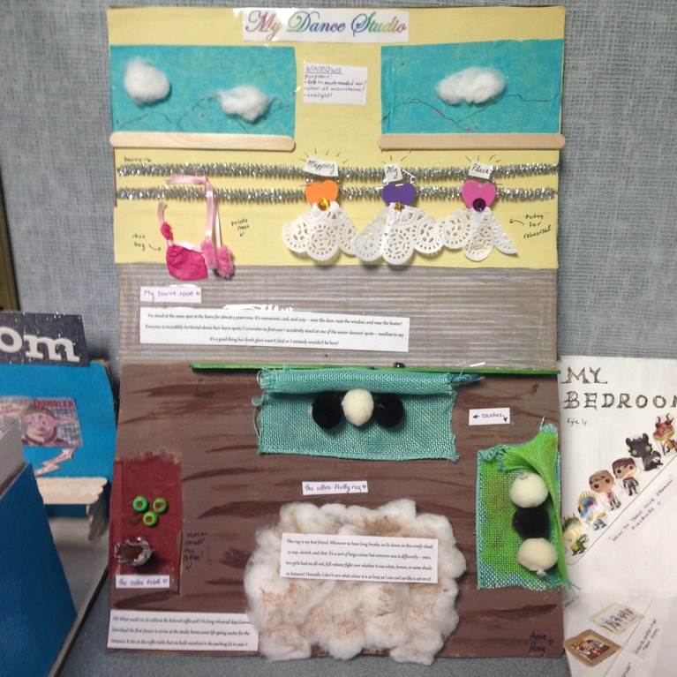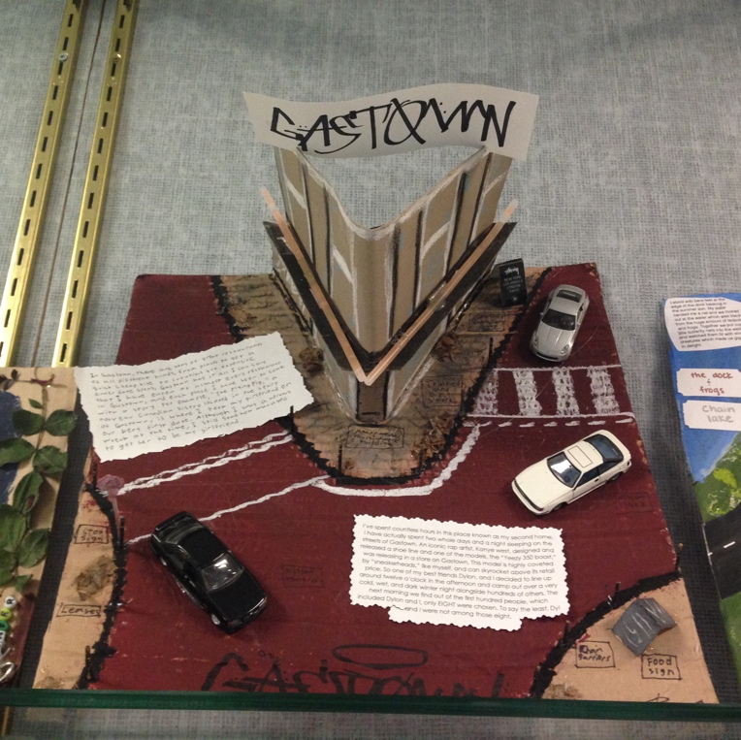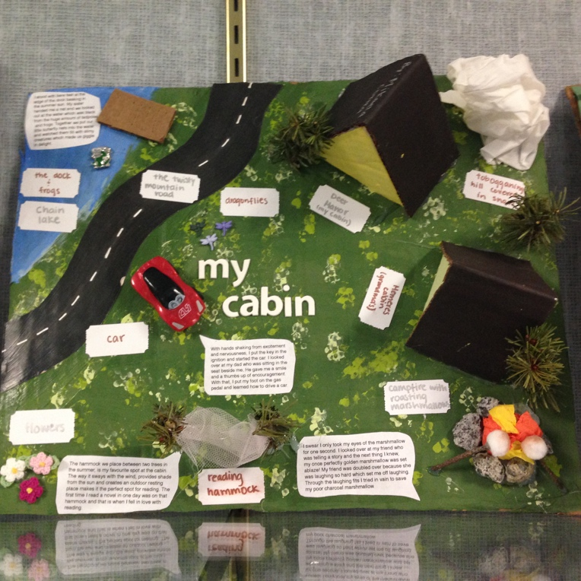

The assessment criteria that I used to for the maps is shown below:

Assessment criteria for map of “Home”

 | Emerging | Developing | Proficient | Extending
Construct meaningful personal connections between self, text, and the world. | May seem incomplete. A limited number of styles of print or multimedia resources. Labels may be missing. The choice of media does not clearly represent the memories, senses, and emotions that you relate to the place. | Either the title or the labels may be missing. Only one style of print is included. Some multimedia resources (3–4) are used. A title and labels are included. The choice of media attempts to represent the memories, senses, and emotions that you relate to the place. | At least 2 styles of print are included and a variety of multimedia resources are used (5). A title and labels are included. The choice of medias most often represents the memories, senses, and emotions that you relate to the place. | Colourful and full of details and images. It is visually appealing and engaging. At least 2 styles of print are included and many (at least 6) multimedia resources are used. A title and labels are included. The choice of media effectively represents the memories, senses, and emotions that you relate to the place.

6. “I Am From” performance poetry
I had students listen to George Ella Lyons’s reading of her poem “I Am From” and follow the provided text. Then, using the clues in the poem and a map of the United States, students tried to identify where and when she lived (born at Harlan, Kentucky, 1949).

Next, I had students watch the opening scene of the documentary, We Are Poets. While watching, students jotted down their observations on the poet’s speaking techniques (pace, inflection, volume, tone) and his writing techniques (poetic devices). Students shared their observations.

Students then viewed a video of Taylor Mali’s slam poem, “Totally Like Whatever.” Afterwards, they engaged in a class discussion about what is more important, what you say or how you say it, and then created an acrostic poem describing good speech in phrases beginning with each letter of the word “speaking.”

Students continued to observe good speech with a sampling of slam and performance poems. Many texts can be found at https://buttonpoetry.com.

I then had students engaged in a gallery walk of stations at which, using a provided poem, they followed the instructions posted and practised different speaking techniques.

Finally, I gave students a sample/model “I Am From” poem, for which they completed a literary device search and assessed it on the assessment rubric shown below. This helped them become more familiar with expectations and criteria for their own writing.

Once they were prepared to write their own “I Am From” performance poem, students began with a pre-write activity, which prompted them to consider various factors that may have contributed to who they are today. Students began drafting their poems, followed by a writer’s workshop and peer feedback.

One the day of the performances, I had transformed the classroom into a cabaret, complete with tablecloths, flower vases, plastic wine glasses and ginger ale. It was a fun day of sharing and celebrating success.

The assessment criteria for the performance poetry is presented in the rubric below:

Senior 4 Point Scale: Performance Poetry Rubric
Assignment: ____________________________________________

Use writing and design processes to plan, develop, and create engaging and meaningful texts for a variety of purposes and audiences.

 | Emerging | Developing | Proficient | Extending
Delivery/  Language | - Speaking techniques are limited or ineffective in usage, including clarity, pace, volume, and inflection  - Limited use of language features, which may be ineffective, failing to convey or derive meaning  - Limited use of non-verbal techniques, which may be ineffective  - Tone and/or form is/ are inconsistent with purpose | Understands and applies some appropriate speaking techniques, including clarity, pace, volume, and inflection  Limited use of language features to derive meaning  Non-verbal techniques are limited but effective  Attempts to use specific tone and form, but they may not be relevant for purpose | Understands and applies a variety of appropriate speaking techniques, including clarity, pace, volume, and inflection  Language features thoughtfully used to convey and derive meaning; may seemed forced  Non-verbal techniques are intentionally and thoughtfully integrated  Attempts to use specific tone and form, but they may not be effectively engaging | - Consciously integrates appropriate speaking techniques, including clarity, pace, volume, enunciation, and inflection to add interest and convey meaning  - Artfully and seamlessly applies oral language features to convey and derive meaning and create rhythm, including: tone, diction, syntax, and rhetorical devices  - Non-verbal techniques, such as gestures, body language, and eye contact, add interest and meaning to speech  - Tone and form of speech are thoughtfully selected to match purpose and influence meaning in an engaging, relevant way
Meaning | - May lose focus of purpose occasionally  - Poem’s meaning is straightforward, familiar, or simple  - Focused on a controlling idea, although that idea may be limited to the concrete subject  - Vocabulary is accurate, but lacks descriptive details  - Attempts sensory detail, but may be ineffective  - Use of poetic devices is limited or may seem forced | May lose focus of purpose occasionally  Poem’s meaning is interesting, but not unique  Vocabulary choices are descriptive and carefully chosen, but limited to denotation  Uses detail and description to create imagery, but may not be maintained throughout poem  Employs multiple poetic devices, but their use may not always be logical or correct | Purpose kept in view throughout  Poem reveals an interesting and unique perspective on subject  Choice of vocabulary is sophisticated, but connotations may not always be appropriate  Employs multiple poetic devices, but their use may not always enhance meaning | - Purpose is clearly articulated  - Poem increases reader’s appreciation or understanding of the subject  - Poem provides a unique interpretation of or insight into subject  - Has an excellent sense of connotation and uses this knowledge to create mood, meaning and imagery  - Employs multiple poetic devices purposefully to enhance meaning
Organization | - May lose focus of purpose occasionally  - Tries to use line breaks and punctuation for effect  - May lose focus of purpose occasionally  - Spelling errors noticeable | Choice of form, line breaks and punctuation aids in the reading of the poem  Clear sequence and sense of direction, but ending is abrupt and/or ineffective  Very few, if any, spelling errors | - Performance has a conclusive and logical ending  - Use of form, line breaks, and punctuation creates rhythm and flow  - Sense of direction, which creates emotional impact  - Very few, if any, spelling errors | - Choice of form, line breaks, and punctuation reflect meaning  - Performance has a powerfully conclusive and logical ending that results in an emotional reaction in audience  - Very few, if any, spelling errors

Summary

Cross-curricular connections
- Art: multi-media map, Roy Henry Vickers’s art
- Social Studies: social injustice of homelessness, neglect, abuse; sense of place, connection between place and identity, importance of place in First Peoples’ text, indigenous trees and their local and cultural significances

Assessment considerations

Formative:
- Think- pair-share on Quindlen essay
- Sort-and-predict of tree images and descriptors
- Pre-writing brainstorming sheet
- Self-check on sense of place reading questions
- Ongoing written and verbal feedback

Summative:
- Roy Henry Vickers–-inspired written artist statement
- Multi-medium, multi-modal map of place
- “I Am From” poem on self

Inquiry-based approach
Students engage in activities and discussions that help them respond to the questions:
- How does our environment influence who we become?
- In what ways does the natural world reflect human experience?
- What is home?

Diverse texts
- The Glass Castle, by Jeanette Walls
- “Homeless,” essay by Anna Quindlen
- My Map Book, picture book by Sara Fanelli
- Selected artwork by Roy Henry Vickers
- The Elders Are Watching, by Roy Henry Vickers
- “I Am From,” poem by George Ella Lyons
- “The Cedar Tree,” poem by Richard Walker
- We Are Poets documentary
- “The Same as Trees,” poem by Nicola Campbell

Inclusive framework
- Multiple entry points (mixture of oral, written, and visual compositions)
- Writing templates and cloze activities available for students
- Graphic organizers or visual mediums to record notes and communicate ideas
- Models and samples
- Oral readings/recordings of the text
- Small and large group discussions – allow students to share ideas and build on their own and others’ insights and ideas
- Self-assessment to support continued learning

