The BIG Mathematical Idea K-1
Students will know and understand:
K: Quantities can be decomposed into smaller parts.
1: Numbers to 20 can be decomposed into 10s and 1s.

Inquiry Question: How many ways can you make 10? How do you see them?

Curricular Competencies  Students are expected to be able to DO the following: | Content  Students are expected to KNOW the following:
Reasoning and analyzing  - Estimate reasonably  - Develop mental math strategies and abilities to make sense of quantities  Understanding and solving  - Visualize to explore mathematical concepts  - Develop and use multiple strategies to engage in problem solving  Communicating and representing  - Communicate mathematical thinking in many ways  - Represent mathematical ideas in concrete, pictorial, and symbolic forms  Connecting and reflecting  - Reflect on mathematical thinking  - Connect mathematical concepts to each other and to other areas and personal interests | Kindergarten  - number concepts to 10  - ways to make 5  - decomposition of numbers to 10  Grade 1  - ways to make 10  - addition and subtraction to 20

Description of Learning Activity
The quantity of 5 is an essential benchmark number for young students, and a strong understanding of 5 will contribute to their understanding of 10, another significant benchmark number in our number system. As the complexity of number increases, the importance of understanding the decomposition of 10 in higher-level operations becomes evident. Every student should be able to show and communicate their understanding of the concepts, and be allowed to represent their understanding through concrete materials, pictures, numbers, or words. Providing opportunities for students to show what they know in a way that makes sense to them is a critical component of the learning experience. Ensure that the required manipulatives and “thinking tools” are accessible. Consider some guiding questions that you might ask to scaffold or extend thinking.
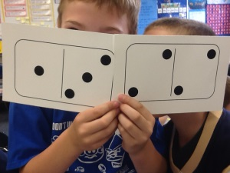
Before
- Read and enjoy any book that models “making 10,” such as Mice Mischief, by Caroline Stills.
- Show various pages of the book and ask: How many do you see? How do you see them?
- Give each student a domino (0—10) and ask them to find another person who they could join to make a quantity of 10.
- Ask the students to identify the two quantities they have found to make a total of 10.
- Model various combinations and have students explain their reasoning.

During
- Read aloud the Inquiry Question and ask they students to discuss how they might approach the question.
- Once the students have heard several strategies, ask them to choose whether to work individually, in pairs, or in small groups to explore the questions.
- Make concrete materials available, such as counters, pattern blocks, or buttons, for students to use.
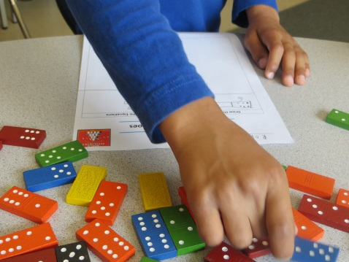
- Ask the students to use the dominoes to make quantities of 5 and 10.
- Ask the students to record pictorially and symbolically the combination of quantities that make 5 and10.
- Circulate, assist students, and ask prompting questions as needed.

After
- Gather the students together to share the various ways they made the quantities of 5 and 10.
- Ask the students to show, explain, and justify how they created various combinations to 5 and10.
- Ask the students to explain the strategies they used.
Considerations

First Peoples Principles of Learning: Creating safe opportunities for learners to articulate and
express their developing identities. (Learning requires exploration of one’s identity.)

Adaptations: Students may need more opportunities to work with ten-frames and two-sided counters to explore ways to make 10.

Extensions: For an extra challenge, have students choose larger quantities of “5 and some more” and “10 and some more.”

Assessment of Learning
Demonstrating understanding of Content through the Curricular Competencies
Choose one or more of the following to assess, depending on the context of your class:
Curricular Competencies  Students are expected to be able to do the following: | Questions to ask to uncover the knowing and understanding:
Reasoning and analyzing  - Estimate reasonably  - Develop mental math strategies and abilities to make sense of quantities | - How did you use benchmarks of 10 to estimate?  - When you explore ways to decompose the number, how can you prove that you have the same quantity?
Understanding and solving  - Visualize to explore mathematical concepts  - Develop and use multiple strategies to engage in problem solving | - When you explore ways to make 10, how can you prove that you have the same quantity of 10?  - How many ways can you make 10? Show your strategies.  - Why did you prefer one strategy over another?
Communicating and representing  - Communicate mathematical thinking in many ways  - Represent mathematical ideas in concrete, pictorial, and symbolic forms | - What did you notice? How did you see 10?  - How would you explain the strategies you used?  - Explain how you solved the problem.  - Describe and compare the different ways you made 10.  - Express your thoughts through pictures, numbers, or words about your discoveries.
Connecting and reflecting  - Reflect on mathematical thinking  - Connect mathematical concepts to each other and to other areas and personal interests | - How did you visualize quantities to solve the problem?  - How is this problem like another one you have solved?  - When might you use what you have discovered/learned?

Student Samples
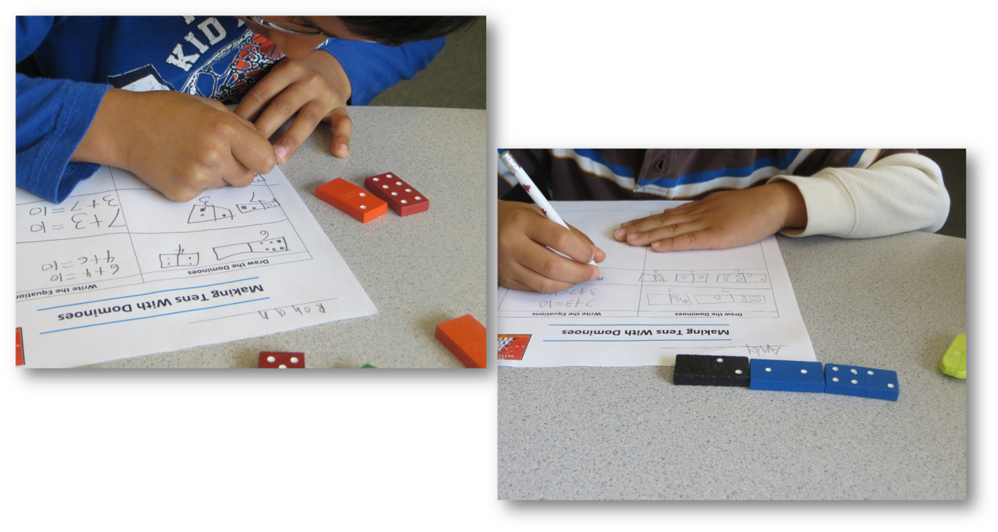

What Next?
• Reflecting on the activity, how might you support or extend students’ understanding?
• Do some of the students need more opportunities to explore this concept?
• What were some common misconceptions?
• Which materials did the students use to build understanding?
• What happens next?

Contributed by Sandra Ball

